Title of the Article

First Author1,*, Second Author2, and Third Author3

1,2Department, Institution, City Zip Code, Country
3Department, Institution, City Zip Code, Country

*Corresponding email: cauthor@email.ac.id

Received: Month xx, xxxx; Revised: Month xx, xxxx; Accepted: Month xx, xxxx.

Abstract: Abstract max. 250 words.

Keywords: keyword 1, keyword 2, keyword 3, keyword 4, keyword 5

1 Introduction
Please, clearly state the introduction, motivation, and contribution of the article here.

2 Research Method
This section is not merely for the research method but also can be modified according to the authors’ necessity. For example, Related Works, Preliminaries, etc.

3 Results

4 Discussion

Table 1: Caption of table

Head 1 | Head 2 | Head 3 | Head 4 | Head 5
Row 1  Row 2  Row 3 | Value 1  Value 5  Value 9 | Value 2  Value 6  Value 10 | Value 3  Value 7  Value 11 | Value 4  Value 8  Value 12

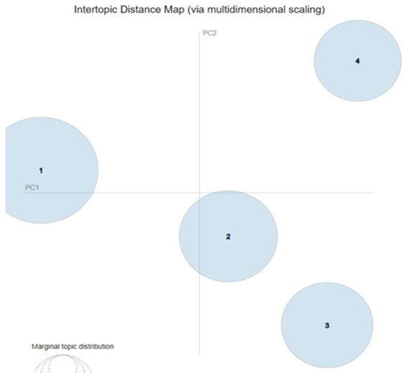

Figure 1: Caption of figure.

5 Conclusion

Acknowledgments

Write the acknowlegment here if any.

References
[1] R. Fardel, M. Nagel, F. Nuesch, T. Lippert, and A. Wokaun, “Fabrication of organic light emitting diode pixels by laser-assisted forward transfer,” Appl. Phys. Lett., vol. 91, no. 6, Aug. 2007, Art. no. 061103.

[2] D. Comite and N. Pierdicca, "Decorrelation of the near-specular land scatter-ing in bistatic radar systems," IEEE Trans. Geosci. Remote Sens., early access, doi: 10.1109/TGRS.2021.3072864. (Note: This format is used for articles in early access. The doi must be included.)

[3] H. V. Habi and H. Messer, "Recurrent neural network for rain estimation using com- mercial microwave links," IEEE Trans. Geosci. Remote Sens., vol. 59, no. 5, pp. 3672-3681, May 2021. [Online]. Available: https://ieeexplore.ieee.org/document/9153027.
Basic format for conference proceedings examples:

[4] D. B. Payne and J. R. Stern, “Wavelength-switched passively coupled single-mode optical network,” in Proc. IOOC-ECOC, Boston, MA, USA, 1985, pp. 585–590.

[5] D. Ebehard and E. Voges, “Digital single sideband detection for interferometric sen- sors,” presented at the 2nd Int. Conf. Optical Fiber Sensors, Stuttgart, Germany, Jan.
2-5, 1984.

[6] PROCESS Corporation, Boston, MA, USA. Intranets: Internet technologies deployed behind the firewall for corporate productivity. Presented at INET96 Annual Meeting. [Online]. Available: http://home.process.com/Intranets/wp2.htp
Basic format for books examples:

[7] G. O. Young, “Synthetic structure of industrial plastics,” in Plastics, 2nd ed., vol. 3, J.
Peters, Ed. New York, NY, USA: McGraw-Hill, 1964, pp. 15–64.

[8] W.-K. Chen, Linear Networks and Systems. Belmont, CA, USA: Wadsworth, 1993, pp.
123–135.

[9] Philip B. Kurland and Ralph Lerner, eds., The Founders’ Constitution. Chicago, IL, USA: Univ. of Chicago Press, 1987, Accessed on: Feb. 28, 2010, [Online]. Available: http://press-pubs.uchicago.edu/founders/

