Visibility study of hybrid solar-wind energy to power up the pump for the irrigation system in the district of Aceh Besar

Author¹, Author^{1,2} Author^{2,*}
¹ Department, Institutions, City + postal code, country
² Department, Institutions, City + postal code, country
³ Department, Institutions, City + postal code, country
*Corresponding author: email address

Abstract
The title is written in Times New Roman Font 11pt, bold, and a capital letter only at the beginning of the word. The abstract must contain a little background, research objectives, methods, and results of about 250 words. All manuscript parts use Times New Roman 10 regular font, except for the Tables and figures, which must be given a caption (title/description) with sequential numbering. The table caption is placed on the left of the table, while the image is placed below the left, and the outline of the image is removed. The number of words is 2500-8000, excluding the abstract and references. The paper size is A4 with 2 columns. All parts have single-line spacing. The author found that the same guidelines were used in this document, so let's look for the related information from any part of the writing. Furthermore, please read the Author's Guidelines before writing an article. You can click the following link:
(http://e-jurnal.pnl.ac.id/index.php/polimesin/about/submissions#authorGuidelines)

Keywords:
List up to 5 keywords here.

1 Introduction
The easiest way to write your article to fit the POLIMESIN Journal writing format is to copy-paste your article into this template. Foreign terms must be written in italics. The decimal writing rules in POLIMESIN Journal follow Mathematics writing rules.
Articles should contain articles that contain 1. Introduction, 2. Research Methods (may include analysis, architecture, methods used to solve problems, implementation), 3. Results and Discussion, 4. Conclusions, 5. Acknowledgments (if any) and References.
A motivated problem and an objective should be narrated and described clearly in this chapter. A research question can be found in this part. The contents of the introduction should contain: (1). Background, (2). A brief literature review (3). The reason for this research and (4). The purpose of the study.
If the review/study of literature must be explained in detail and length, then a separate subtitle may be made in the title. 2. The title of the research method and the subsequent titles will follow the serial number of the title after the serial number of the review/study literature.

2 Research methodology
To solve the problem in subchapter 2.2.1, a methodology is introduced. All the material, equipment, and techniques to answer the research question is described in this chapter. As the research needs a contribution, some comparison with the previous work might be mentioned to show the significance of the research. Research answers as well the comparison need to be validated.

2.1 Formatting
Two-column layout with width: 96 mm and column spacing 6 mm. Before writing, adjust the margins of your article to top/ bottom/left/right, in order: 6, 12, and 6 mm. On the tab "page setup/Layout respectively, header and footer: 0 and 6 mm.
Tables and figures must be given a caption (title/description) with sequential numbering. The table caption is placed on the left of the table, while the image is placed below the left, and the outline of the image is removed.

2.1.1 Heading
The heading is formatted in Times New Roman, size 10, and bold. The hierarchy is 1, 1.1, and 1.1.1. There is no full-stop mark after the last number. There is also no line spacing between the heading and the following paragraph, including lower heading hierarchy.

2.1.2 Paragraph
Indentation 5 mm is used, and line spacing is single. When a picture, table, or figure splits a paragraph, the following lines must be without any indentation.

2.1.3 Picture
The figure should be a maximum of 96 mm for one column and 198 mm for two columns. It is preferable to have a figure magnified up to the maximum width. If a figure annotation or any part of the figure is not readable in one column size, it is presented in two columns using the menu layout>break>section break> continuous. The Figure caption is written below it. If the caption only has one line, it is centered and justified; if 2 or more lines.
The figure must be sharply presented without any blur or distortion. Any figure with a drawing line needs 1000 dpi to keep it sharp enough. On the other hand, a photograph could be a 300 dpi.
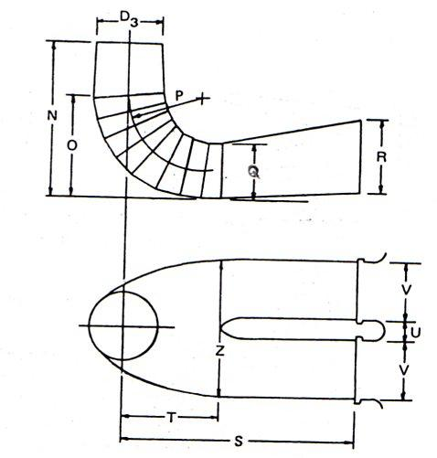
Fig. 1. Sample image (table (Justify if more than 1 line
A figure with many parts needs annotation. Every part is named by the annotation with an arrow that directs to the part, not to the annotation itself.

2.1.4 Table
The table width should be a maximum of 96 mm for one column and 198 mm for two columns. Table captions are always justified without indentation. A related SI unit must follow any dimension at the column heading.
Table 1. Justified
Column heading | Column A (t) | Column B (T)
And an entry | 1 | 2
And another entry | 3 | 4
And another entry | 5 | 6
The table properties are preferable to have font size 10pt. In some cases where the table contains a lot of character and look overload, the font size could be selected between 8-10pt. When the smallest font size can not adapt in the one-column table, it needs to be expanded in two columns by the same figure setting. A row could be specified as high as 4mm-5mm for a line.

2.1.5 Equation
The equation is written with sequential numbering placed to the right. If the equation is too long, use splitting. The equation referring sentence must be at least one time before the equation as formulated in Eq. (1).

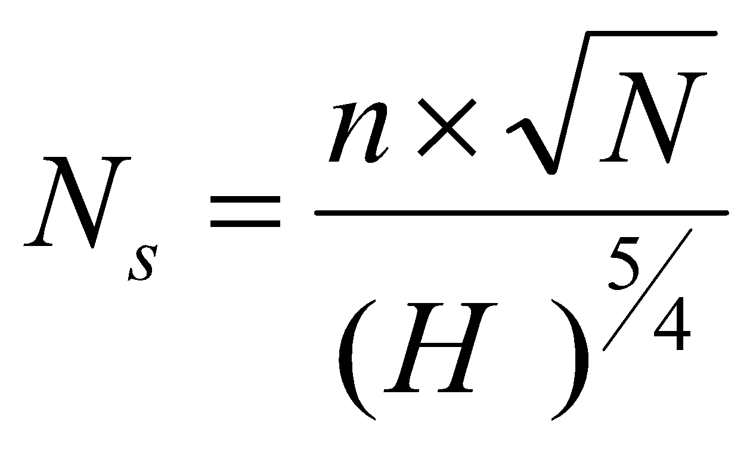
(1)

2.1.6 Abbreviation
Abbreviation is only defined the first time in the abstract section and in the chapters. It is followed by the abbreviation in a bracket. In case an abbreviation is already popular among people, not only scholars and academics in a field of study, it is not necessary, such as: Direct Current (DC), Alternating Current (AC), International Standard Organization (ISO), etc.

2.2. Submission

2.2.1 Affiliation
Affiliation needs only 4 parts: department, intitution and city of intitution with post code and country.
- Department is any unit name in the institution such as: “Department of Mechanical Engineering”. In the case, the faculty name is not stated. So, in any institution, it is only a smaller unit at the department level.
- Institutions in the bigger unit at the institution level, such as “State Polytechnic of Lhokseumawe”
- City with it’s post code. There is no comma between the city and the post code.

2.2.2 Corresponding author
He/She is the only person who submitted the manuscript using the email mentioned in the manuscript through the Open Journal System (OJS). Additional communication between the editor and reviewer using email and WhatsApp is also only conducted by the author.
Changing the corresponding author is not permissible. So let authors decide before submission who becomes the first name, second, the others one, and corresponding author before a manuscript is submitted. In some cases, sponsorship of a research or school regulation strictly decides the author's name position and corresponding author assignation in a manuscript. Any change in the position later will not only affect the journal's accreditation but also the author's institution. Such request could lead the editor to request a statement letter from a different manuscript from the same institution before further processing a new manuscript.

2.3 Revision by author
Download a base file for revision as in the green square, neither the red one nor the other files. The red one is only an informational file forwarded by the editor to the author once a reviewer finishes their task. As shown in Fig. 2, the author needs to wait for a decision (blue square) by the editor before conducting any revision to avoid unnecessary revision because of a declination or resubmission.

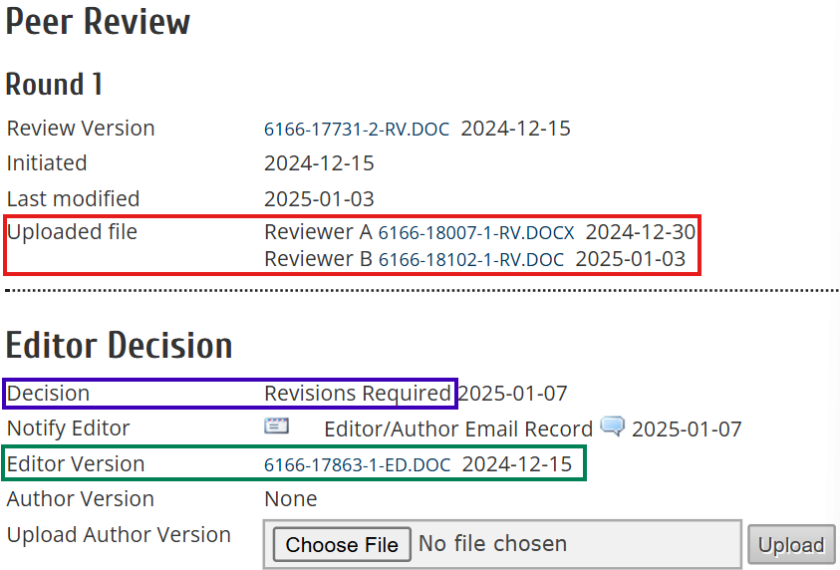
Fig. 2 Author’s decision and revision uploading page

Upload this revised “Editor Version” file as a completed version with all reviewer comments, related author response, and intended revised manuscript.
Instructions to revise a reviewed manuscript is followed by author properly to expedite manuscript to the publicaatiin schedule (Fig. 3).

2.4 Substance
Explain the research method used. Explain briefly but still accurately, such as size, volume, replication, and workmanship techniques. The new process must be detailed so other researchers can reproduce the experiment. At the same time, established methods can be explained by picking out references.
The main body of the research article contains: (1) Introduction (includes background, a little literature review, and research objectives); (2) Research methodology; (3) Results and discussion; and (4) Conclusions.

3 Results and discussion

3.1. Formatting

3.1.1 Dimension and unit
The International Standard (IS) or metric is fully implemented to format all parts of writing related to numbers, dimensions, and units. Any number in imperial standard is converted to the metric (Table 2). The unit must use the standard to avoid misunderstanding among readers.

Table 2. Dimension and unit in metric
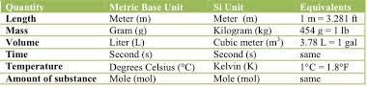

3.1.2 Number
In number, the decimal is noted by a point. In scientific writing, number is written fully for thousand without comma, such as: water density: 1000 kg/m^3 and gravity: 9.81 m/s^2. For a bigger number, it will be written as tensile stress of steel: 400-700 MPa.

3.2 Subtance
The series of research results is based on a logical sequence/arrangement to form an explanation. The contents indicate facts/data and do not discuss the results. Can use Tables and Numbers, but not repeat the same data in figures, tables, and text. To further clarify the description, you can use subtitles.
Discussion is the basic explanation, relationship, and generalization shown by the results. The description answers the research question. If there are doubtful results, then display them objectively.
The result is normally shown as a graph and table as the effect of methodology. result is not mean as an equipment or material itself.

4 Conclusions
In conclusion, there must be no reference. The conclusion contains the facts obtained, enough to answer the problem or research objective (do not be a discussion again); State the possible applications, implications, and speculations accordingly. If needed, provide suggestions for further research. Any significant in the chapter 2, 3 are described in this chapter.

References
All references to cited material must be placed at the end of the manuscript.. Quotations (Citations) written in writing or text must be numbered. The number is given following the order in the text and corresponds to the number in the reference used and written at the end of the published document. Standards for writing citations on IEEE can be explained briefly as follows:
- Each number in the quotation must be enclosed in square brackets ([..]) parallel to the text, before the quotation marks, and spaces before the use of square brackets.
- It is not necessary to include either the author or the date of the reference unless it is relevant to the text used. It should be written as follows: "in reference [26] ..."
At least 50% of articles are from the last 10 years, 30% are from the last 5 years, and no more than 20% of books. It is recommended to write a library using Mendeley or similar software to facilitate citation.

